**Bahria University, Lahore Campus**

Department of Computer Science

Lab Journal 13

**(Spring 2023)**

|  |  |  |
| --- | --- | --- |
| Course: | **Data Structures and Algorithm - Lab** | Date: _______________ |
| Course Code: | CSL-221 | Max Marks: 10 |
| Faculty’s Name: | Fatima Zulfiqar |  |

Name: _____________________ Enroll No: ___________________ Class: ______________

Objective(s):

Upon completion of this lab session, learners will be able to:

* Implement directed and undirected graph data structure
* Implement weighted directed / undirected graphs
* Insert new vertex and edges to weighted / non-weighted directed / undirected graphs
* Implement Depth First Search (DFS) algorithm and find path between two vertex

## Lab Tasks:

**Task 1**

Create separate classes for directed and undirected graph respectively using either adjacency list or adjacency matrix representation. Include methods to add a new vertex, add an directed/undirected edge, and determine if an directed/undirected edge exists between two vertices.

**Directed Graph**

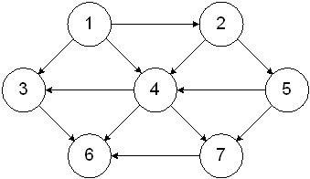

**Undirected Graph**

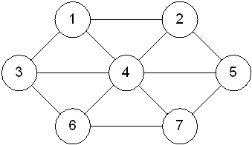

**Task 2**

Extend **Task 1** and Implement a weighted graph data structure using an adjacency list / adjacency matrix representation. Include methods to add a new vertex, add a weighted edge, and find the weight of an edge between two vertices.

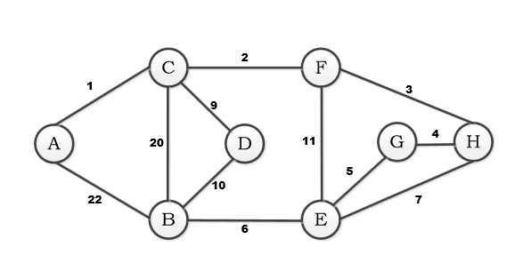

**Task 3**

Using Weighted Directed Graph designed in **Task 2,** implement a method to perform a depth-first search (DFS) traversal starting from vertex **A** towards vertex **G**.

**Note : Attempt all tasks and get them checked by your Lab Instructor. Also for each task, attach a screenshot of the output. You are free to use any other helping functions in your code.**

**Lab Grading Sheet :**

|  |  |  |  |
| --- | --- | --- | --- |
| **Task** | **Max Marks** | **Obtained Marks** | **Comments(*if any*)** |
| 1. | 4 |  |  |
| 2. | 2 |  |  |
| 3. | 4 |  |  |
| **Total** | **10** |  | **Signature** |